A000-AM,C-Taino-Cemi-*Maquetaurie Guayaba*- Porphyritic Steatite-1000 CE

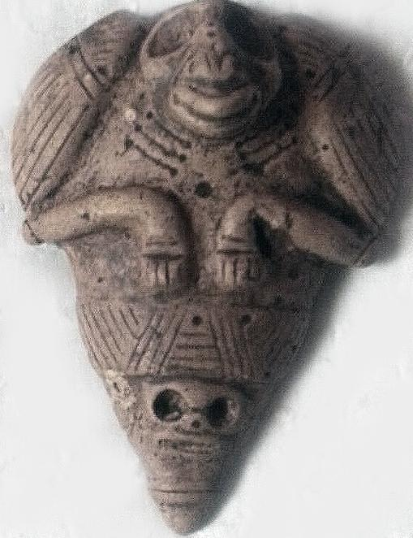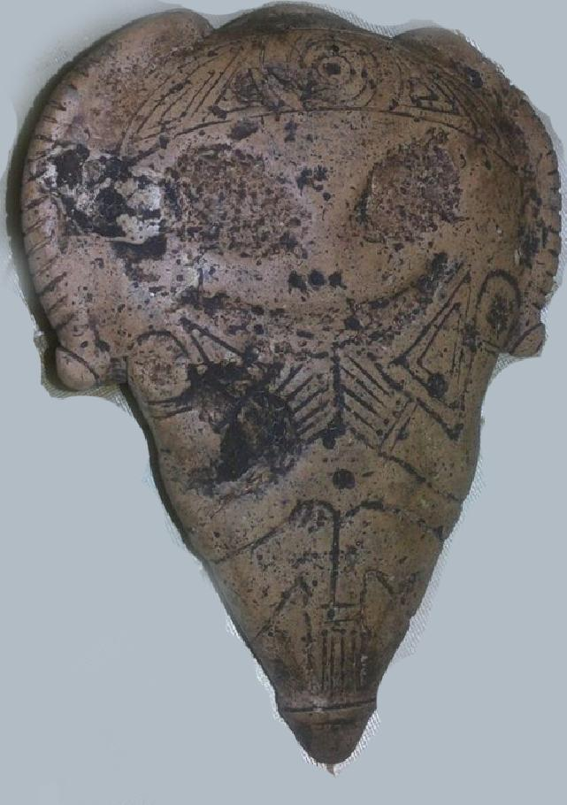

Anthropomorphic *cemi* (spirit) of *Maquetaurie Guayaba*, Lord of the Dwelling Place of the Dead, *Coaybay. c* 900-1500 CE, height 7 in.

This celt*Maquetaurie Guayaba* is the skull mask at the bottom of the figure with hollow circular eyes and skeletal teeth (signifying death). A bird, probably a nocturnal bird, perhaps an owl, that has a clearly defined navel, which signifies that it is a bird of the living world, is transporting this figure. Owls were revered as the avian counterparts of the spirits of the dead with their haunting nocturnal calls. Consequently, Taínos were reluctant to travel into the forests at night as this was the owl’s realm and was also considered to be the realm of deceased ancestors. The right-hand (obverse) image shows *Maquetaurie Guayaba* with an with his skeletal countenance surmounted by a skull and both hands placed to the mouth as though having divulged a secret. This side of the figure is probably intended to be a body stamp used with the black juice of the fruit of the tropical tree *Psidium paniferum,* traces of which may still be adhering to its surface

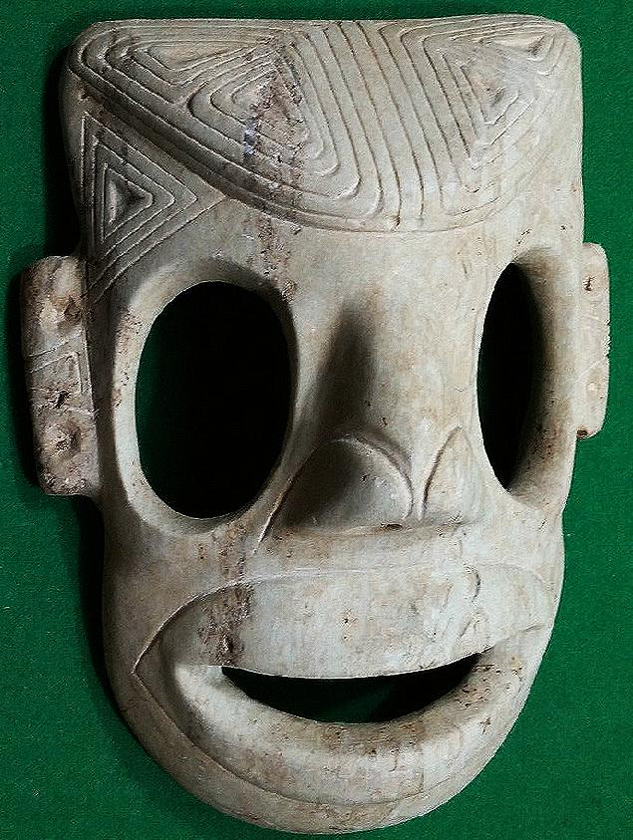

Anthropomorphic Mask: Length: 9 1/8 in., marble. Dominican Republic. 1200-1500 AD/CE.

This very rare, large mask carved from marble by a master sculptor probably shows *Maquetaurie Guayaba* again with an inviting countenance. The elaborately sculpted ears, the temples and the cranium are inscribed with a triangular motif that recalls the shape of the tri-pointed or three-pointed stone sculptures that evoke both the shape of the holy Taíno mountain, Cauta, and the shape of the mounds in which the Taíno grew their staple food, yucca. This mask might have been similar to the one used in the ceremony recounted by Columbus:

References

Pané, Fray Ramon. 1999. *An account of the antiquities of the Indians*. A new edition, with introductory study, notes, & appendices by José Juan Arrom. Translated by Susan C. Griswold. Durham and London: Duke University Press.

Stahl, Don Augustin. 1899. “The Fauna and Flora of Porto Rico”. In Elihu Root, *Collection of United States Documents*, (Washington: Government Printing Office) 222-230.